Blog May 2014

MANY LOW-FAT FOODS HAVE ADDED SUGAR
5/30/2014
1 COMMENT

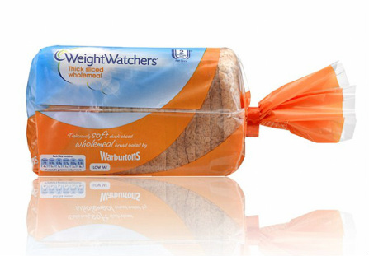Low-fat bread and other foods can contain more calories than regular versions
Stands to reason really I suppose; you reduce the fat in prepared foods, according to conventional dieting wisdom and you lose both taste and texture. So you add emulsifiers and thickeners for an improved consistency and extra sugar for taste.
I don't usually link to the Daily Mail but in this case, they are running an article based on Dr Capehorne's presentation at the recent European Congress on Obesity in Sofia, Bulgaria. Read this excerpt:
"Dieters choosing low-fat foods in the hope of cutting calories should beware: they can contain even more calories than regular foods, research has found.
While most low-fat supermarket products contain a third fewer calories than their regular fat version, 10% actually have more or the same calories, mainly due to added sugars.
Weight Watchers wholemeal thick slice bread had more calories than any own label, regular fat equivalent, and Weight Watchers sliced cheese also had more calories than own label equivalents.
Obesity specialist Dr Matthew Capehorn said weight-conscious shoppers should realise that choosing low-fat products made by brands including Weight Watchers could hamper their efforts to cut calories."
Read more: http://www.dailymail.co.uk/health/article-2643644/Many-low-fat-foods-SAME-calories-regular-equivalents-added-sugar-say-researchers.html#ixzz33GpsJK5d
About Weight Watchers
This is just a gentle reminder that Weight Watchers is not just about being a jolly group of people getting together to try and reduce weight by cutting calories. The global company is also a 5 billion dollar plus business and one of the world's leading consumer brands with the same bottom line financial goals as other private companies and interestingly, run by a very private person - Raymond Debbane.
According to Forbes magazine, when H.J. Heinz put its Weight Watchers unit on the block in 1999, Debbane bought the company in a $735 million leveraged buyout. His fund, Artal, put down $224 million in the deal and the company financed the rest of the acquisition with debt. Since then, Artal has pocketed $3.8 billion by selling stock and collecting dividends. In addition, Artal still retains a 52% stake in Weight Watchers, worth about $1.4 billion (back in 2012).
In other words, the $224 million Debbane invested in Weight Watchers in 1999 is now worth some $5.2 billion in what has become a giant ATM, generating cash by delivering weight management services marketed by Jennifer Hudson, Jessica Simpson and Charles Barkley.
Full article at: www.forbes.com/sites/nathanvardi/2012/09/04/the-mystery-man-behind-weight-watchers-and-the-private-equity-deal-of-the-century/

1 Comment

RECESSION HAS HAD NO EFFECT ON RISING CONFECTIONARY SALES
5/30/2014
0 COMMENTS

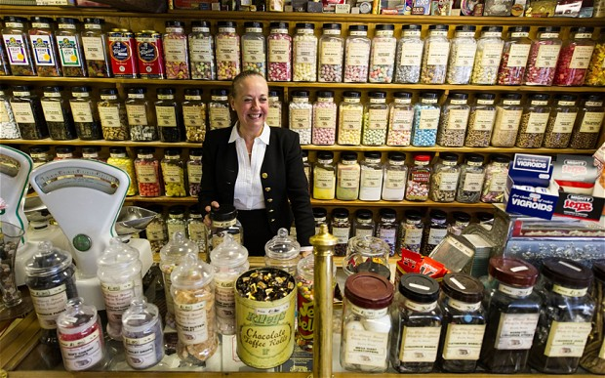
The UK's oldest sweet shop; photo by Jonathon Pow
Good times for chocolate makers  Time was when sweets were a real treat, eaten in small quantities and served up in small paper bags. But that was a long, long time ago. The days of Willy Wonka are long gone.  Compare the shopping experience in the UK’s Oldest Sweet Shop which has been selling sweets in the market town of Pateley Bridge since 1827, with W H Smith’s approach on the right. Now of course, it’s all about quantity and special offers, and it's no wonder our sugary consumption has exploded in recent years.  Just look at the industry figures for the fastest growing segment of all, namely chocolate confectionery.  The recession does not seem to have affected sales of these affordable sugary 'carbolicious' treats which sadly does not augur well for remarkable similar obesity and diabetes projections - which are also recession proof! | 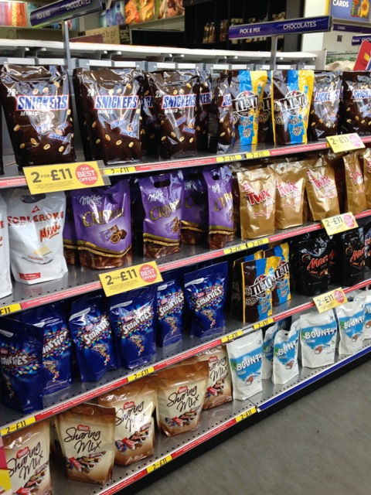  Display of sweet stuff at W H Smith (used to be a bookshop)
0 Comments

EGG WHITE OMELETTE SIR?
5/29/2014
1 COMMENT

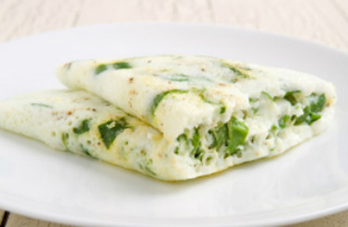Not what an omelette should look like
The egg-white craze: it's no yolk!
As reported in The Guardian, there is a national egg-white shortage in the US after a rise in demand for yolk-free omelettes, sandwiches and shakes. Do you ditch the tastiest, most nutritious part of the egg?
Here is an excerpt from the report:... Having just returned from a trip to Los Angeles, where I can confirm that it's virtually a crime in some parts of the city to eat the yellow bit of an egg.For the moment, the UK is being spared the joys ofMcDonald's Egg White Delight, but our appetite for whites does seem to be sharpening. Egg-white omelettes now appear as standard breakfast fare on many UK restaurant menus... And it looks as though lots of our kitchens are becoming yolk-free zones.
"Demand for egg whites is definitely growing in the UK," says Anna Richey who heads up the Two Chicks liquid egg white business. "Egg whites are almost a unique product, as they're fat-free, cholesterol-free, low carb and high protein. Our customers are people who are health conscious and we have lots of demand from people such as rugby players who might put 15 egg whites into their breakfast shake.The article continues: Although yolks are high in fat and cholesterol, scientists now believe the role they play in raising cholesterol levels is very small and they are actually the most nutritious (not to mention best-tasting) part of the egg.The LCHF approach encourages you to eat whole eggs.

1 Comment

RE-FRAME TO SWITCH THE BLAME
5/26/2014
0 COMMENTS

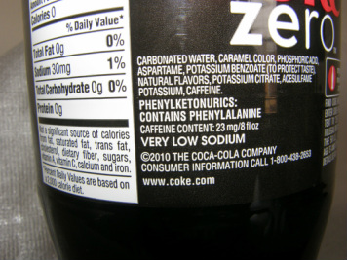Coke Zero - no calories, no harm?
You’ve got to hand it to the food industry guys; they are clever… always coming up with new ideas. And this time, it’s the turn of Coca Cola on behalf of the soft drinks industry as they continue to re-frame the current obesity/diabetic (diabesity) crisis in their own terms.
Let's blame a lack of exercise
You see; it sound so logical. We’ve all become so sedentary, haven’t we? Our kids too; that’s why more exercise programmes and sports initiatives are needed to help reduce weight… and as a result; that’s why we in the soft drinks industry are doing our bit to help by sponsoring such activities…
Now exercise is indisputably a good thing in which to engage. The body benefits in many ways as does the brain. But research has shown that exercise only plays a minor role when it comes to ‘fixing’ the obesity/diabesity epidemic which is continuing to grow day-by-day.
The real culprits are refined starches, such as breakfast cereal, bread, cookies, etc., and sugar as shown admirably in the new film Fed Up (see trailer), but back to our story...
Even Michele Obama got roped in as a food industry spokesperson with her ‘Let’s Move’ programme. She said that it would “… help create and promote a program that could potentially take a massive step in the right direction for controlling the childhood obesity epidemic.” Please don’t get me wrong; I repeat; exercise is highly beneficial, but by focusing on this minor part of the diabesity equation, she is playing into the food industry’s hands. “It’s not our fault that kids eat much more processed starch and sugar - they should simply exercise more,” seems to be their industry sponsored mantra.
Former Olympic athlete and organiser of the 2012 Olympic Games in London, Sebastian Coe, is the latest victim to get caught out, playing into the hands of the food and drinks industry as they fight to force through their re-framing of the issue. He has leant his name to the new Coca Cola UK scheme called Coca Cola Zero ParkLives, where 70 parks in London, Birmingham and Newcastle will offer free activities to local communities, in particular targeting families and young adults. The marketing scheme will run this summer, then for six months next year, with plans to expand it to more cities between now and 2020. Local authorities are short of funds so not surprisingly, they have jumped on this initiative. And Coca Cola claims to be “making major strides to help tackle obesity in Britain, with 40% of its sales now involving ‘zero calorie’ versions.”
How does Sebastian Coe endorse the campaign? “The next 10 years must be about capturing the spirit of the extraordinary summer of 2012 and converting it into lasting change. I am delighted to support Coca-Cola Zero ParkLives to bring business, local authorities and communities together to help people to move more, in local parks which are loved by communities and open to all.”
You cannot dispute that Seb Coe’s heart is clearly in the right place, just like Michele Obama's, but he is unwittingly helping to shift the public perception of the obesity issue away from 'excessive consumption of sugary and sugar-ersatz carbonated drinks' to 'a lack of exercise'.

0 Comments

KERRY'S VERSION OF GRANOLA
5/17/2014
0 COMMENTS

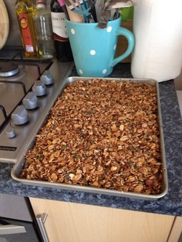Kerry's Granola
Great to see Kerry's version of this granola recipe on Facebook... "a little darker but smells great" she says... and that's a lovely home-baking smell she's referring to.
All ovens are a bit different, with actual temperatures and air circulation leading to unique patterns. Also; some people like a more toasted flavour, others not.
Kerrry cooked in bulk because she's busy (duh) and also because individual portion sizes are small when you make this LCHF staple and eat with fresh Greek-style yogurt for example. A quantity like this can keep you going for weeks when stored in an air-tight container. Granola can also be 're-crispened' in a warm oven for 5 minutes if there's ever too much and it loses it's crunch but... somehow there never seems to be!
A note on the health side for those of you dialling up your Omega-3 levels. There's lots of crunch coming from the nuts and larger seeds but make sure you grind up as much linseed (aka flax) as possible. It contains more Omega-3 than all other plant based foods and even most fish. Also, chopping in some fresh walnuts dials the levels up even higher if you don't like the grittiness of the ground seeds.
Summary: Healthy, nutritious, delicious!

0 Comments

EUROPEAN OBESITY DAY, SATURDAY MAY 17TH
5/16/2014
0 COMMENTS

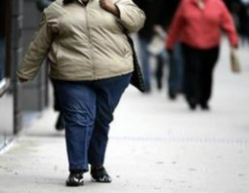Belgian street scene, courtesy of Le Vif
Yes; Saturday May 17th is the day! Except nothing is happening anywhere; no events, speeches, no nothing.
National governments are not taking obesity seriously enough. They don't even support the official Annual Obesity Day... and neither does the European Union!
"European Obesity Day, is held annually on the third Saturday of May. In all Europe, the day brings together politicians and medical communities, at public events. The goal of EOD is to motivate and support overweight European citizens to make the necessary lifestyle changes to reach and maintain a healthy weight and improve their health and quality of life.
About half of the European population is obese or at least overweight, which brings major consequences for health care and the economy.
The number of people who suffer obesity is constantly rising, and it is an especially big problem for children. It can have impact on learning abilities and psychological conditions of the children, and of course the physical health issues are huge.
These include diabetes, but also heart problems and other issues. This also counts for adults who suffer from it. It is estimated that about 8% of the health costs in the EU are related to obesity, and about 10% of the deaths."
That's taken from the official eu website (last updated on May 17 2011) which suggests you click on:http://www5.obesityday.eu/
... but if you do, it turns out that the website is for sale!

The European Union's Obesity Day website is up for sale. Any takers?
In Belgium, who speaks up for those with problems of obesity
In Belgium, there no longer even a representative association of obese patients. They lost their financial support in 2013.According to Belgium’s Vif/L’Express magazine, Jean-Paul Allonsius, the former President of Bold (the Belgian association of obese patients) also says that the Belgian government does not take the problem of obesity enough to heart. "The state still does not consider obesity as a chronic illness. Much multi-disciplinary care, such as consulting a psychologist or a dietician is not reimbursed by the state. You cannot just tell people to eat less", he complains . "The government should also remove VAT on fresh vegetables allowing everyone to eat healthy", says the activist... and there we wholeheartedly agree.
Weight-loss surgery drops in Sweden, hits new highs in Belgium
One of those countries where obesity is hitting less hard is Sweden – maybe in some small part because it is home to the LCHF (low carb, high fat) movement. Weight-loss surgery there has also gone down for the second year running.
The number had steadily risen to 8,500 people undergoing surgery for their obesity in 2011, but in 2012, a total of 8,050 such surgeries were carried out dropping to 7,700 in 2013 according to their Registry of Obesity Surgery.
Contrast that to Belgium where according to figures from the Inami, 8,574 obese patients opted for a "gastric bypass" or an equivalent technique in 2013 , against 8,173 in 2012 and less than 1,000 back in 2007.
Although they are lower down in the European rankings, over 20% of children in Belgium between 5 and 9 years already show an alarmingly high body mass index (latest available figures from 2008). Even in Belgium, overall levels of obesity have soared since 1997 and according to the statisticians, it appears to be the least educated people who are 2 to 3 times more likely to become obese than those with more education .
0 Comments

5 A DAY; DOES ANYONE UNDERSTAND WHAT IT MEANS?
5/16/2014
0 COMMENTS

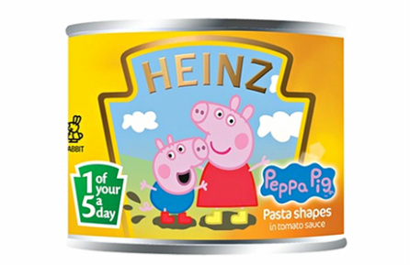Nice how the 5 a day logo mimics the Heinz branding :)
With all the talk about increasing from 5 portions of fruit and veg to ‘7 a day’, Paula Cocozza of the Guardian has just published a great explanatory article on the ‘5 a day’ slogan and why it does not work. Here are a few excerpts but please also read the full article.
… Retailers use the five-a-day labelling more routinely on products with a higher profit margin – prepared fruits and salads, packaged vegetables and so on. Loose fruits and vegetables, usually the cheapest option, are rarely labelled as one of your five a day, whether you shop at Iceland or Tesco. At Waitrose, the link between higher-cost products and the five-a-day labelling is even more apparent.
… Consider a shopper at an out-of-town retail park who wishes to buy some pineapple to satisfy one of her five a day. First, she goes into Marks & Spencer and finds a pack of prepared fruit for £2, promising one of her five a day – even though at 260g it actually comprises more than three portions. Next, she goes into Waitrose and finds that if she buys her chopped pineapple here, she need eat only eight chunks to have eaten a portion of fruit. At Asda, she can buy a tiny slice of pineapple for 50p, weighing exactly 80g, and one of her five a day. At all these stores, a whole, fresh pineapple – the more economical purchase – carries no five-a-day marketing at all. Not on the fruit (understandably) but not on the shelf either.
At the time of writing, there are well over 400 comments; some of them provide entertainment, some are really well expressed. Here are two examples, selected by The Guardian staff:
“It's what happens when you dumb down nutritional guidance instead of raising the knowledge and awareness of healthy eating. I'd like to see schools do more to educate pupils on healthy eating and where all pupils are required to attend cooking classes rather than it being a choice subject. Maybe groups for young parents after school or in the holidays too. Get kids and parents working together, making it fun as well as educational. Me.....I don't count my 5 a day, but if forced to, I'd recommend 'seven a day'. Five being vegetables and two being fruit. A portion is roughly a hand full.”
“It isn't though. Because the portion sizes vary. And you're only allowed two fruit. Following botanical definitions, cucumbers, squash, tomatoes and peppers and aubergines are fruits. And rhubarb is a vegetable. And where do pulses, nuts and grains fit in. They're not vegetables. And then we're supposed to pretend some roots and tubers are vegetables, and others aren't. So it's as clear as mud.”

0 Comments

THE BIG FAT SURPRISE
5/12/2014
0 COMMENTS

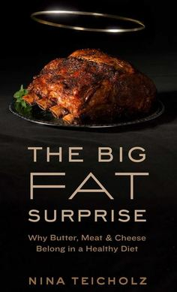
We're just half way through the year and hot off the heels of the premiere of Fed Up which demonizes sugar, comes a new book which 'decriminalizes' fat.
The investigative journalsit, Nina Teicholz calls the low-fat nutrition advice of the past sixty years "a vast uncontrolled experiment on the entire population, with disastrous consequences for our health."
She continues: "For decades, we have been told that the best possible diet involves cutting back on fat, especially saturated fat, and that if we are not getting healthier or thinner it must be because we are not trying hard enough. But what if the low-fat diet is itself the problem? What if the very foods we’ve been denying ourselves—the creamy cheeses, the sizzling steaks—are themselves the key to reversing the epidemics of obesity, diabetes, and heart disease?"
Based on a nine-year-long investigation, Teicholz shows how the misinformation about saturated fats took hold in the scientific community and the public imagination, and how recent findings have overturned these beliefs. She believes that nutrition science has gotten it all wrong; that overzealous researchers, through a combination of ego, bias, and premature institutional consensus, have allowed dangerous misrepresentations to become dietary dogma.
Nina Teicholz uses scientific research and anecdotal evidence to show that we have been needlessly avoiding meat, cheese, whole milk, and eggs for decades and that we can now welcome these foods back into our lives.

0 Comments

WATCH 'FED UP': THE NEW FILM ON THE DANGER OF SUGAR
5/11/2014
0 COMMENTS

Researchers behind the new documentary film, Fed Up, found that of the 600,000 food items in the US, a staggering 80 per cent have added sugar, and that fast-food chains and the makers of processed foods add more sugar particularly to 'low fat' foods to make them more palatable.

https://youtu.be/aCUbvOwwfWM
Some quotes to think about from the film:
- Dr Mark Hyman, chairman for the Institute for Functional Medicine, says “…sugar is a 'fundamental problem' which no-one is talking about” and he goes on to say: “The message has been pushed onto us: it is your fault you're fat. Forget about it.”
- Dr David Kessler, a former Food and Drug Administration commissioner, predicts that the obesity crisis fuelled by sugar will end up as 'one of the greatest public health epidemics of our time'. “We are toast as a country”, he tells the film.
- Gary Taubes: “blaming willpower for obesity - as has been the way for several years - is a 'crime'.”
- Obesity, claims the film, could be started by the human brain's reaction to sugar. “The brain 'lights up to sugar just as it does with cocaine and heroin'” says Dr Hyman. "So effectively, people who are unwittingly eating sugar will over time become addicted to it."
- Michael Pollen, writer of the book The Omnivore's Dilemma, says that by not implementing laws to stop so much sugar being used, the government is effectively 'subsiding the obesity epidemic'.
- Mark Bittman, a columnist for the New York Times tells the film how junk food companies are acting like 'tobacco companies were 30 years ago'. Why not watch the trailer...
0 Comments

